Degrees
# Source: AI Source: Provided by: [Data Path: Persons Table -> ID Column: 1, Name_En Column: Motasem Essam] -> From: [ChatGPT] on [7/25/2026]
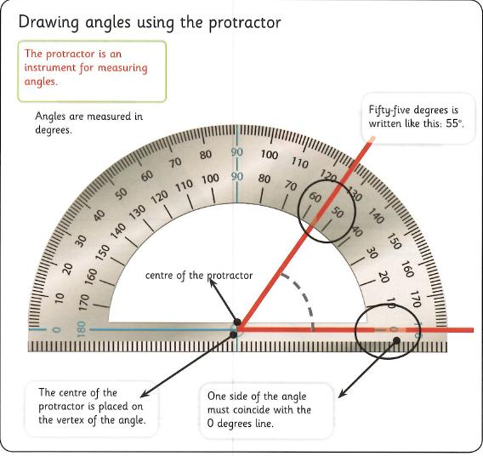
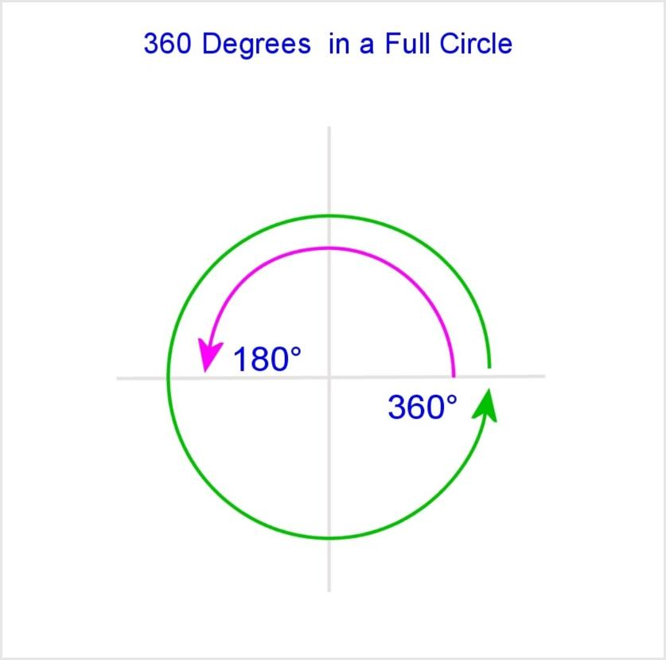
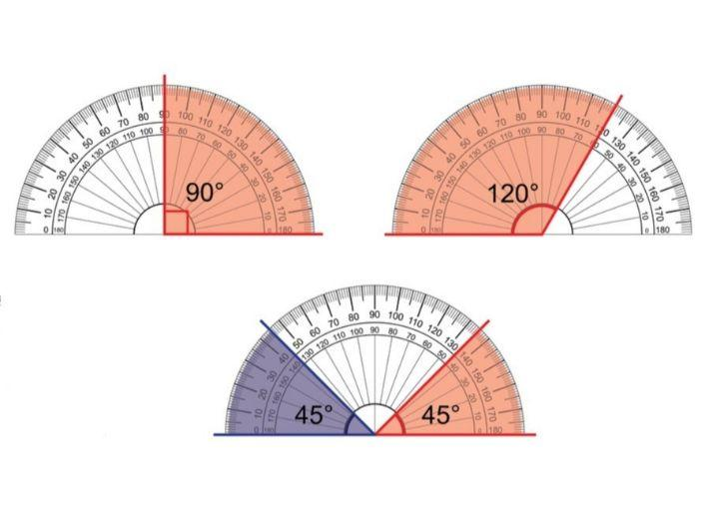
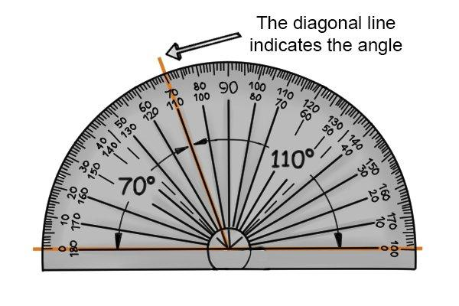
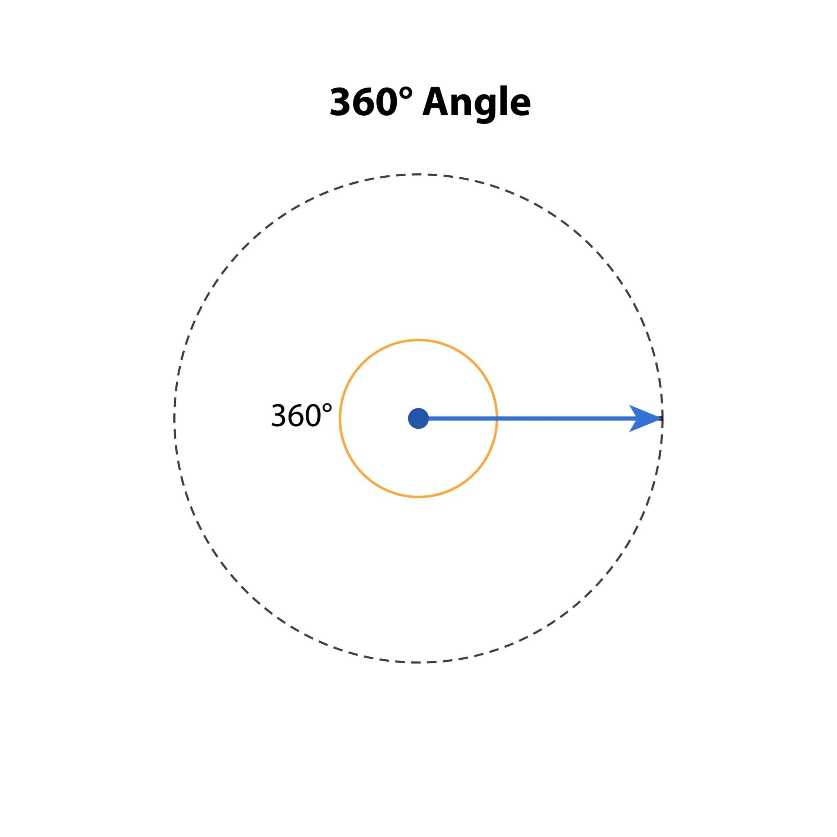
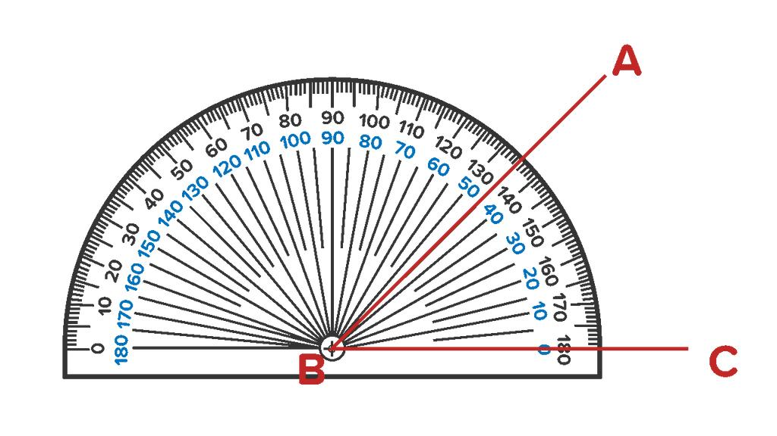

Definition
# Source: AI Source: Provided by: [Data Path: Persons Table -> ID Column: 1, Name_En Column: Motasem Essam] -> From: [ChatGPT] on [7/25/2026]
A Degree is the most commonly used unit for measuring angles. It represents one part of a full rotation divided into 360 equal parts.
The degree is denoted by the symbol:
$${}_{​}^{∘}​$$
Thus:
$$1^{∘}$$
means one three-hundred-sixtieth of a complete revolution.

Historical Background
# Source: AI Source: Provided by: [Data Path: Persons Table -> ID Column: 1, Name_En Column: Motasem Essam] -> From: [ChatGPT] on [7/25/2026]
The degree originated from ancient Babylonian mathematics, which used a base-60 (sexagesimal) numeral system.
Because a circle was divided into:
$$360$$
equal parts, one degree became:
$$\frac{1}{360}$$
of a complete circle.

Symbol
# Source: AI Source: Provided by: [Data Path: Persons Table -> ID Column: 1, Name_En Column: Motasem Essam] -> From: [ChatGPT] on [7/25/2026]
The degree symbol is:
$${}_{​}^{∘}​$$
Examples:
$${45}^{∘}$$
$${90}^{∘}$$
$${180}^{∘}$$

Complete Rotation
# Source: AI Source: Provided by: [Data Path: Persons Table -> ID Column: 1, Name_En Column: Motasem Essam] -> From: [ChatGPT] on [7/25/2026]
One complete revolution equals:
$${360}^{∘}$$
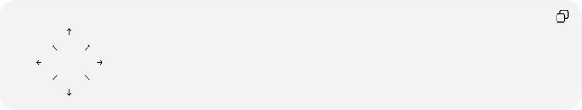
↑
↖ ↗
← →
↙ ↘
↓

Relationship with Other Angle Measurements
# Source: AI Source: Provided by: [Data Path: Persons Table -> ID Column: 1, Name_En Column: Motasem Essam] -> From: [ChatGPT] on [7/25/2026]
Degree and Radian
A straight angle equals:
$${180}^{∘}=π\text{ radians}$$
Therefore:
$$1^{∘}=\frac{π}{180}\text{ radians}$$
Conversely:
$$1\text{ radian}=\frac{{180}^{∘}}{π}$$

Common Angle Measurements
# Source: AI Source: Provided by: [Data Path: Persons Table -> ID Column: 1, Name_En Column: Motasem Essam] -> From: [ChatGPT] on [7/25/2026]
Angle Type | Degree Measure
Zero Angle | $$0^{∘}$$
Acute Angle | $$0^{∘}<θ<{90}^{∘}$$
Right Angle | $${90}^{∘}$$
Obtuse Angle | $${90}^{∘}<θ<{180}^{∘}$$
Straight Angle | $${180}^{∘}$$
Reflex Angle | $${180}^{∘}<θ<{360}^{∘}$$
Complete Angle | $${360}^{∘}$$

Fractional Parts of a Circle
# Source: AI Source: Provided by: [Data Path: Persons Table -> ID Column: 1, Name_En Column: Motasem Essam] -> From: [ChatGPT] on [7/25/2026]
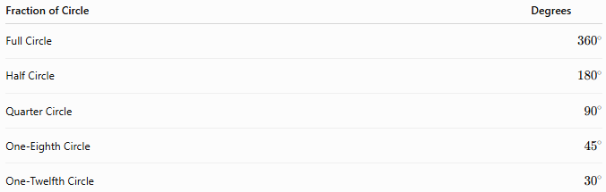
Fraction of Circle | Degrees
Full Circle | $${360}^{∘}$$
Half Circle | $${180}^{∘}$$
Quarter Circle | $${90}^{∘}$$
One-Eighth Circle | $${45}^{∘}$$
One-Twelfth Circle | $${30}^{∘}$$

Degrees, Minutes, and Seconds
# Source: AI Source: Provided by: [Data Path: Persons Table -> ID Column: 1, Name_En Column: Motasem Essam] -> From: [ChatGPT] on [7/25/2026]
A degree can be divided into smaller units.

Minutes
# Source: AI Source: Provided by: [Data Path: Persons Table -> ID Column: 1, Name_En Column: Motasem Essam] -> From: [ChatGPT] on [7/25/2026]
$$1^{∘}=60'$$
where:
- $'$ represents minutes of arc.

Seconds
# Source: AI Source: Provided by: [Data Path: Persons Table -> ID Column: 1, Name_En Column: Motasem Essam] -> From: [ChatGPT] on [7/25/2026]
$$1'=60''$$
Therefore:
$$1^{∘}=3600''$$
where:
- $''$ represents seconds of arc.

Examples
# Source: AI Source: Provided by: [Data Path: Persons Table -> ID Column: 1, Name_En Column: Motasem Essam] -> From: [ChatGPT] on [7/25/2026]
Example 1
Convert:
$$2^{∘}$$
to minutes.
Solution:
$$2×60=120'$$

Example 2
Convert:
$${1.5}^{∘}$$
to degrees and minutes.
$$1^{∘}+{0.5}^{∘}$$
Since:
$$0.5×60=30'$$
Answer:
$$1^{∘}30'$$

Example 3
Convert:
$$30'$$
to degrees.
Since:
$$60'=1^{∘}$$
then:
$$30'=\frac{30}{60}={0.5}^{∘}$$

Measuring Angles in Degrees
# Source: AI Source: Provided by: [Data Path: Persons Table -> ID Column: 1, Name_En Column: Motasem Essam] -> From: [ChatGPT] on [7/25/2026]
Angles measured in degrees are commonly measured using a protractor.
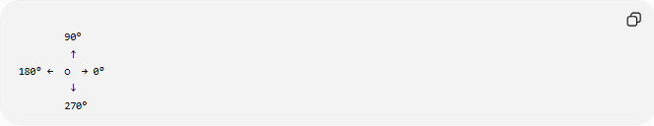
90°
↑
180° ← ○ → 0°
↓
270°
The protractor scale ranges from:
$$0^{∘}$$
to
$${180}^{∘}$$

Real-World Examples
# Source: AI Source: Provided by: [Data Path: Persons Table -> ID Column: 1, Name_En Column: Motasem Essam] -> From: [ChatGPT] on [7/25/2026]
Degrees are used in:
- Clock hands.
- Navigation.
- Surveying.
- Construction.
- Engineering.
- Architecture.
- Robotics.
- Computer graphics.
- Aviation.
- Astronomy.

Applications
# Source: AI Source: Provided by: [Data Path: Persons Table -> ID Column: 1, Name_En Column: Motasem Essam] -> From: [ChatGPT] on [7/25/2026]
Degrees are widely used in:
- Plane Geometry
- Coordinate Geometry
- Trigonometry
- Surveying
- Navigation
- Civil Engineering
- Mechanical Engineering
- Robotics
- Architecture
- CAD (Computer-Aided Design)
- Physics

Advantages
# Source: AI Source: Provided by: [Data Path: Persons Table -> ID Column: 1, Name_En Column: Motasem Essam] -> From: [ChatGPT] on [7/25/2026]
Using degrees:
- Is intuitive.
- Matches common measuring tools.
- Simplifies geometric construction.
- Is universally taught in elementary geometry.
- Is convenient for practical measurements.

Limitations
# Source: AI Source: Provided by: [Data Path: Persons Table -> ID Column: 1, Name_En Column: Motasem Essam] -> From: [ChatGPT] on [7/25/2026]
Degrees:
- Are less convenient than radians for advanced calculus.
- Require conversion when using many mathematical formulas.

Comparison with Other Angle Units
# Source: AI Source: Provided by: [Data Path: Persons Table -> ID Column: 1, Name_En Column: Motasem Essam] -> From: [ChatGPT] on [7/25/2026]
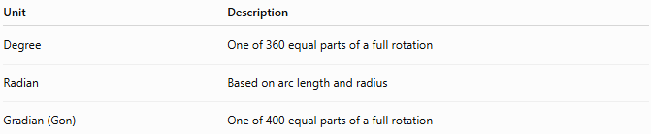
Unit | Description
Degree | One of 360 equal parts of a full rotation
Radian | Based on arc length and radius
Gradian (Gon) | One of 400 equal parts of a full rotation

Key Points
# Source: AI Source: Provided by: [Data Path: Persons Table -> ID Column: 1, Name_En Column: Motasem Essam] -> From: [ChatGPT] on [7/25/2026]
- A Degree is:
$$\frac{1}{360}$$
of a complete rotation.
- Symbol:
$${}_{​}^{∘}​$$
- Relationships:
$${360}^{∘}=2π\text{ radians}$$
$${180}^{∘}=π\text{ radians}$$
$$1^{∘}=60' \\ 1'=60''$$

Conclusion
# Source: AI Source: Provided by: [Data Path: Persons Table -> ID Column: 1, Name_En Column: Motasem Essam] -> From: [ChatGPT] on [7/25/2026]
A Degree is the standard unit used to measure angles in geometry. It divides a complete rotation into 360 equal parts, making it practical for measuring and describing rotations and angular relationships. Degrees are fundamental in plane geometry, coordinate geometry, trigonometry, surveying, engineering, architecture, navigation, robotics, CAD, computer graphics, and physics, where accurate angle measurement is essential for design, analysis, and real-world applications.

